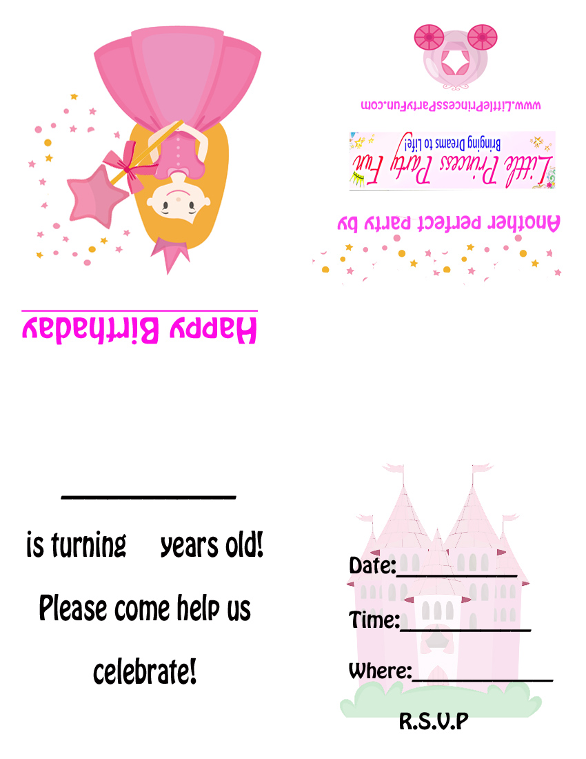

**HAPPY BIRTHDAY**

RSVP via text or email (by: ) to:

*Message to Parents:*